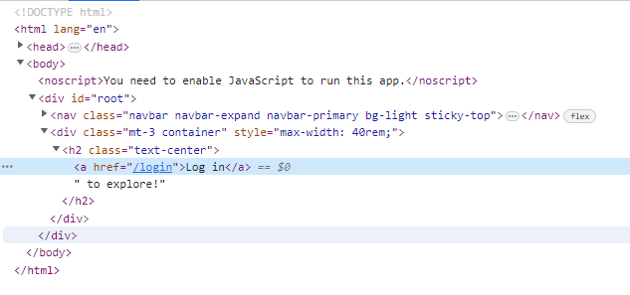

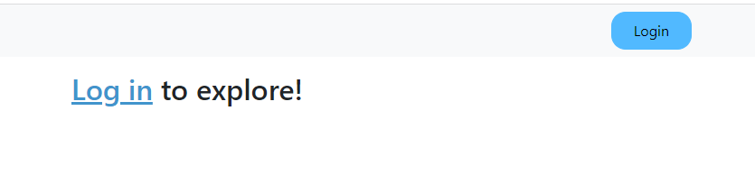

To click on Log in link

 await page.click('h2 > a')

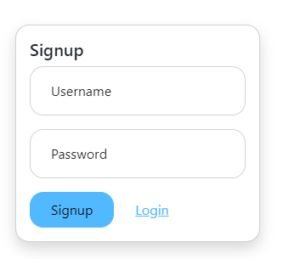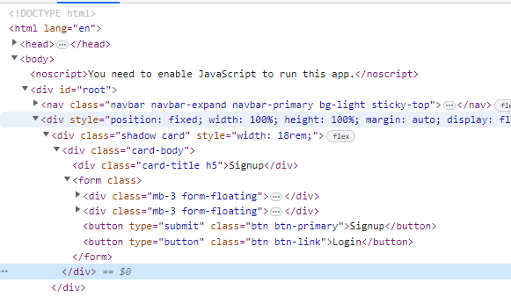

await page.click('form button.btn.btn-primary');

3)login user

<form class="" xpath="1">

<div class="mb-3 form-floating">

<input placeholder="Username" type="text" id="formUsername" class="form-control">

<label for="formUsername">Username</label>

</div>

<div class="mb-3 form-floating"><input placeholder="Password" type="password" id="formPassword" class="form-control">

<label for="formPassword">Password</label></div>

<button type="submit" class="btn btn-primary">Login</button>

<button type="button" class="btn btn-link">Signup</button></form>

  await page.click('form button:nth-of-type(1)');

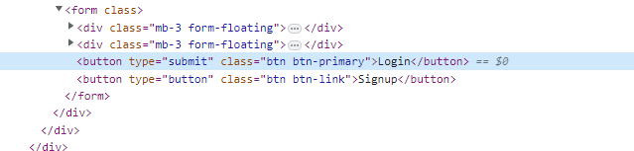

4)invalid credentials

const loginmessage=await page.locator('div.alert.alert-danger')

        await expect(loginmessage).toContainText('Invalid credentials.')

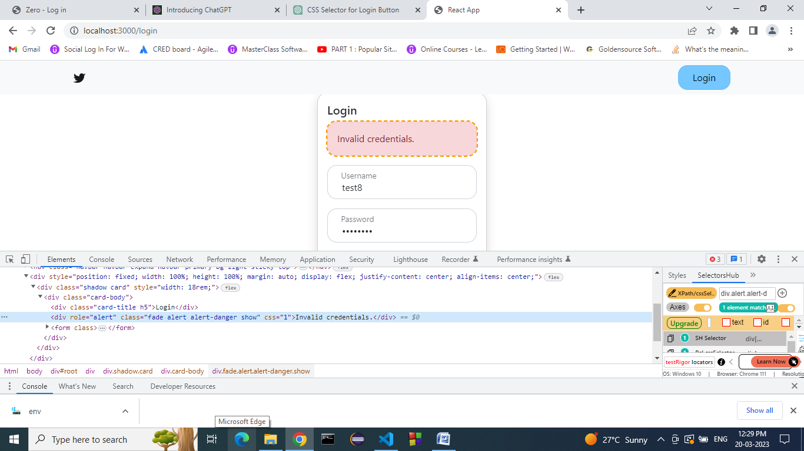

**Selectors by naveen automation**

1)Text selector

<form class="">

<div class="input-group">

<input placeholder="New comment..." type="text" class="form-control" value="">

<button type="button" class="btn btn-primary">Post</button>

</div>

</form>

button[type='submit']

5)Xpath-https://getbootstrap.com/docs/4.0/components/dropdowns/

<div class="dropdown">

<button class="btn btn-secondary dropdown-toggle" type="button" id="dropdownMenuButton" data-toggle="dropdown" aria-haspopup="true" aria-expanded="false">

Dropdown button

</button>

<div class="dropdown-menu" aria-labelledby="dropdownMenuButton">

<a class="dropdown-item" href="#">Action</a>

<a class="dropdown-item" href="#">Another action</a>

<a class="dropdown-item" href="#">Something else here</a>

</div>

</div>

1. //div[@class='dropdown']//button[@type='button' and @class='btn btn-secondary dropdown-toggle' and @id='dropdownMenuButton'] if id not present use this format
2. //button[@id='dropdownMenuButton']

//div[@class='dropdown'] -parent

6)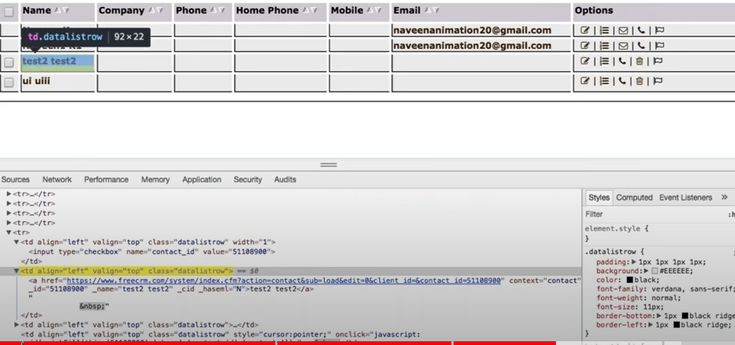

**++preceding-sibling:**

//a[text()='test2 test2']//parent::td[@class='datalistrow']//preceding-sibling::td[@class='datalistrow']

**++parent & preceding-sibling:**

//a[text()='test2 test2']//parent::td[@class='datalistrow']//preceding-sibling::td[@class='datalistrow']//input[@name='contact_id']

To click on checkbox of test2,test3 instead of doing for loop ,use xpath

* Here <tr> has three children ,3 brothers,now we are in second brother,to go to first brother use preceding-sibling,to go for 3rd brother use forward-sibling
* <td>has input has child
* Here the parent of a is td,who is sibling of td its td above and td below
* To go to parent use,parent followed by double semicolon and child(td)
* First go to parent then come to preceding sibling

//a[text()=’test2 test3’]//parent::td[@class=’datalistrow’]//preceding-sibling::td[@class=’datalistrow’]//input[@=’name=contact_id’]

**For clicking ui uiii**

//a[text()=’ui uiii’]//parent::td[@class=’datalistrow’]//preceding-sibling::td[@class=’datalistrow’]//input[@=’name=contact_id’]

Some Good Examples:

++link: Features

1. //a[text()='Features'] 2.
2. //a[contains(text(),'Features')] --recommended

++button:

1. //button[@type='button' and @class='btn']
2. //button[contains(text(),'Sign Up')] //div[@class='dropdown']//button[@type='button' and @class='btn btn-secondary dropdown-toggle' and @id='dropdownMenuButton']
3. //button[@id='dropdownMenuButton']

To select Joe.Root checkbox,use xpath this way

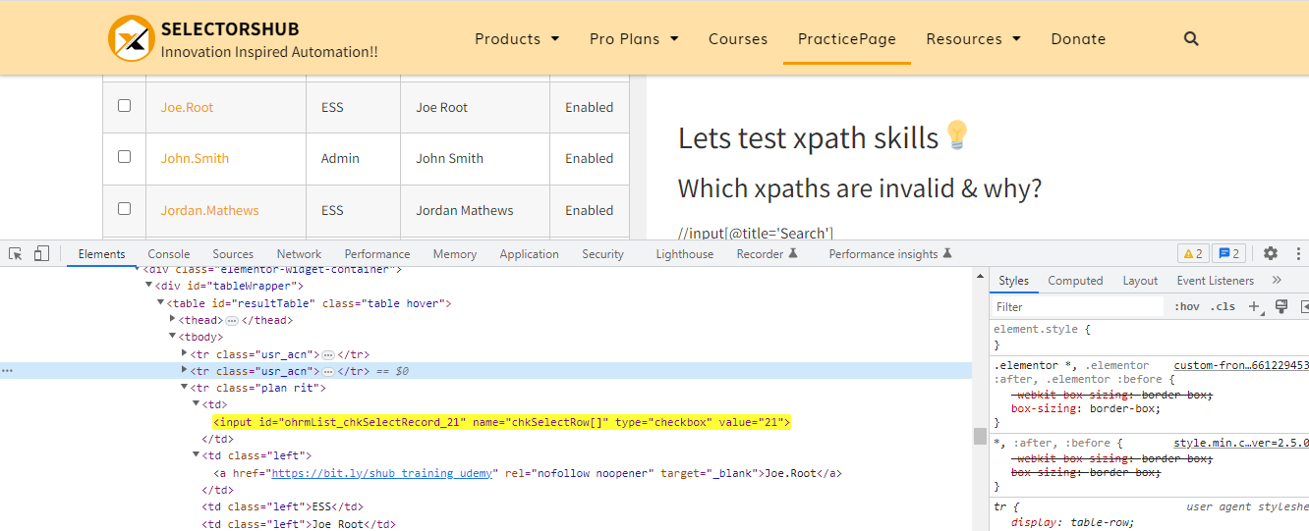

//a[text()='Joe.Root']/parent::td/preceding-sibling::td/input[@type='checkbox']

To select John.Smith checkbox

//a[text()='John.Smith']/parent::td/preceding-sibling::td/input[@type='checkbox']

To select John Smith text in John.Smith row

//td[text()='John Smith']

To select all in webtable

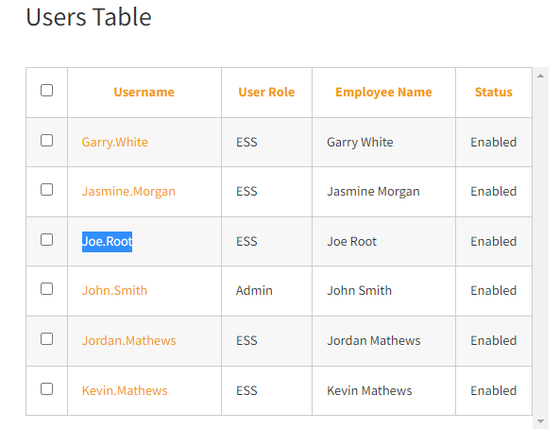

Locator checkboxes=page.locator(“//table[@id=’resultTable’]//input[@type=”checkbox”]”);

for(int i=0;i<checkboxes.count();i++)

{

checkboxes.nth(i).click();

}

* //table[@id='resultTable']//input[@type='checkbox'] 1 of 7 ,use for loop
* //input[@type=”checkbox”] –grandchild so use // instead of /
* (//table[@id='resultTable']//input[@type='checkbox'])[3] selects Jasmine.Morgan
* (//table[@id='resultTable']//input[@type='checkbox'])[last()] selects [Kevin.Mathews](https://bit.ly/shub_training_udemy)
* (//table[@id='resultTable']//input[@type='checkbox'])[position()=4] selects Joe.Root

Can use indexing also

(//table[@id='resultTable']//input[@type='checkbox'])[1] selects username

(//table[@id='resultTable']//input[@type='checkbox'])[2] selects Garry>white

page.locator(“(//table[@id='resultTable']//input[@type='checkbox'])[1]”) .click();

page.locator(“(//table[@id='resultTable']//input[@type='checkbox'])[last()]”).click();

you can also write like this

page.locator(“xpath=(//table[@id='resultTable']//input[@type='checkbox'])[1]”) .click();

N-th element selector

Consider 4 buttons

button button button button

“button >> nth=0” //first

“button >>nth=-1” //last

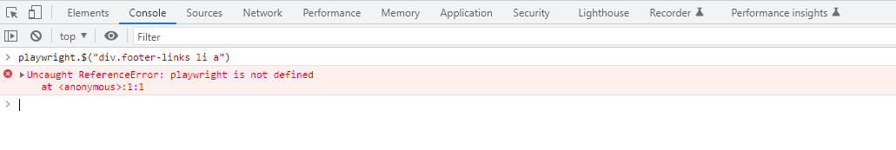

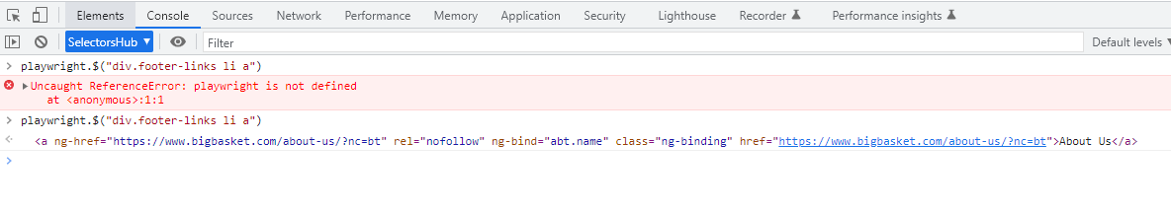

$$ shows total available links for About us

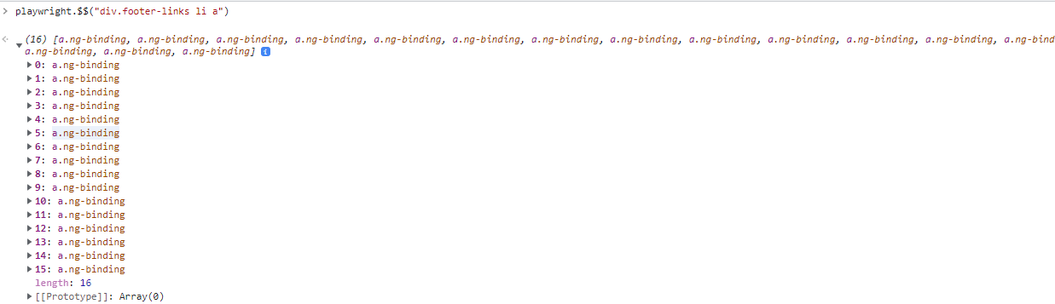

Bigbasket.com

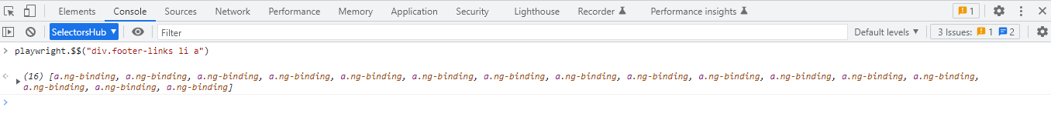

playwright.$("div.footer-links li a >> nth=0")

<a ng-href=​"https:​/​/​www.bigbasket.com/​about-us/​?nc=bt" rel=​"nofollow" ng-bind=​"abt.name" class=​"ng-binding" href=​"https:​/​/​www.bigbasket.com/​about-us/​?nc=bt">​About Us​</a>​

playwright.$("div.footer-links li a >> nth=-1")

<a ng-href=​"https:​/​/​bbvendorconnect.saturam.com/​" rel=​"nofollow" ng-bind=​"hlp.name" class=​"ng-binding" href=​"https:​/​/​bbvendorconnect.saturam.com/​">​Vendor Connect​</a>​

playwright.$("div.footer-links li a >> nth=5")

<a ng-href=​"https:​/​/​www.bigbasket.com/​terms-and-conditions/​?nc=bt" rel=​"nofollow" ng-bind=​"abt.name" class=​"ng-binding" href=​"https:​/​/​www.bigbasket.com/​terms-and-conditions/​?nc=bt">​Terms and Conditions​</a>​ppagepage

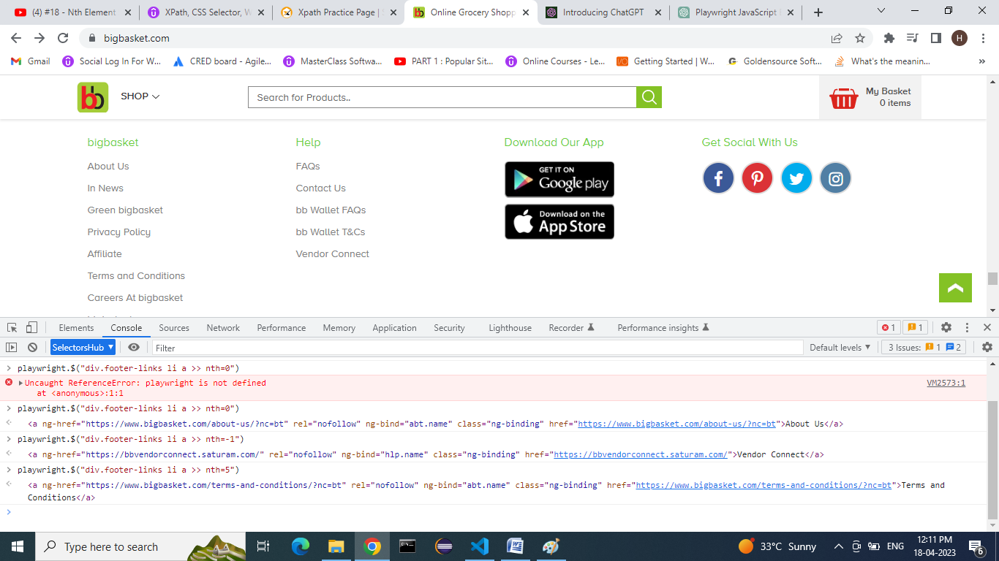

Locator first_ele=page.locator(“div.footer-links li a >> nth=0”);

String firstEle=first_ele.textContent();

System.out.println(firstEle);

first_ele.click();

Locator last_ele=page.locator(“div.footer-links li a >> nth=-1”);

String lastEle=last_ele.textContent();

System.out.println(lastEle);